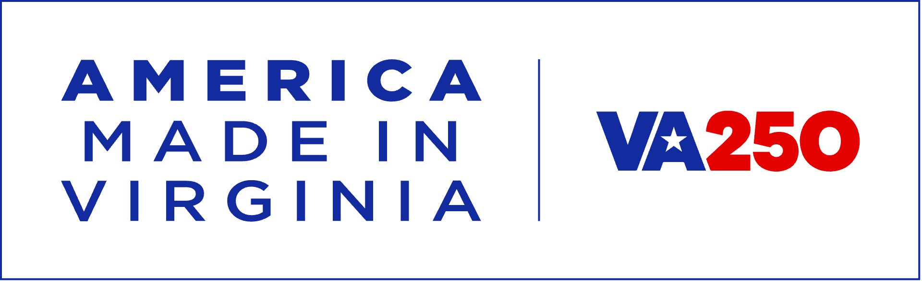
The Virginia Campground Association is proud to be a Commemorative Partner of VA250—The Virginia American Revolution 250 Commission. Of the thirteen original colonies, none played as fundamental a role as Virginia in the formation of our country. From the ideas that inspired it, to the battlefields that decided it, there is simply no America without it. As we mark 250 years of Independence, now is the perfect time for you to reconnect with your country in the place that made it possible. Please join us at VA250.org. You may log in here for the digital toolkit including logos and marketing copy you are free to use:
https://live.standards.site/va250-toolkit
Password: 1776AMERICA
If you need assistance with any of these materials, please reach out to info@virginiacampgrounds.com.

